

**FAKE REVIEW DETECTION USING DEEP LEARNING**

**A PROJECT REPORT**

***Submitted by***

**Deepadharsan M (1920102027)**

**Dhanush V (1920102030)**

**Dhanushwar B (1920102724)**

***in partial fulfillment for the award of the degree***

***of***

**BACHELOR OF ENGINEERING**

***In***

**COMPUTER SCIENCE AND ENGINEERING**

**SONA COLLEGE OF TECHNOLOGY**

**(An Autonomous Institution)**

**SALEM-636005**

**ANNA UNIVERSITY: CHENNAI-600 025**

**MAY 2024**



**FAKE REVIEW DETECTION USING DEEP LEARNING**

**A PROJECT REPORT**

***Submitted by***

**Deepadharsan M (1920102027)**

**Dhanush V (1920102030)**

**Dhanushwar B (1920102724)**

***in partial fulfillment for the award of the degree***

***of***

**BACHELOR OF ENGINEERING**

***In***

**COMPUTER SCIENCE AND ENGINEERING**

**SONA COLLEGE OF TECHNOLOGY**

**(An Autonomous Institution)**

**SALEM-636005**

**ANNA UNIVERSITY: CHENNAI-600 025**

**MAY 2024**

**ANNA UNIVERSITY: CHENNAI 600 025**

**BONAFIDE CERTIFICATE**

Certified that this project report **“FAKE REVIEW DETECTION USING DEEP LEARNING”** is the Bonafide work of **“DEEPADHARSAN M (1920102027), DHANUSH V (1920102030), DHANUSHWAR B (1920102724)”** who carried out the project work under my supervision.

|  |  |
| --- | --- |
| **SIGNATURE** | **SIGNATURE** |
| **Dr. B. SATHIYABHAMA**  Professor, | **Ms. K. S. JAYAREKA**  Assistant professor, |
| Head of the department | Supervisor |
| Department of Computer Science and  Engineering | Department of Computer Science and Engineering |
| Sona College of Technology, Salem – 636005 | Sona College of Technology, Salem – 636005 |

Submitted for the project viva-voce examination held on ………...

**INTERNAL EXAMINER EXTERNAL EXAMINER**

**CONFERENCE CERTIFICATES**







**PROCEEDINGS**

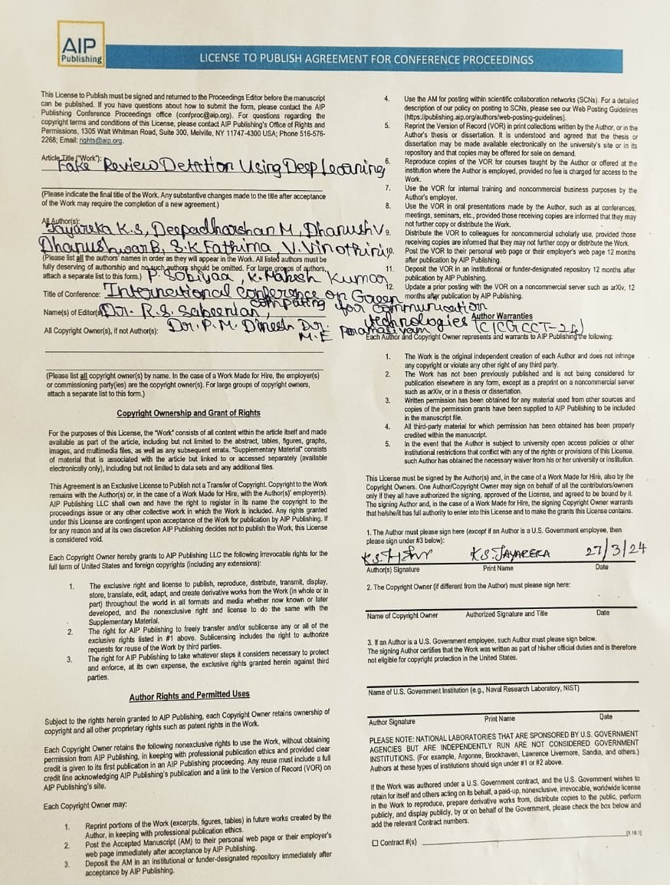

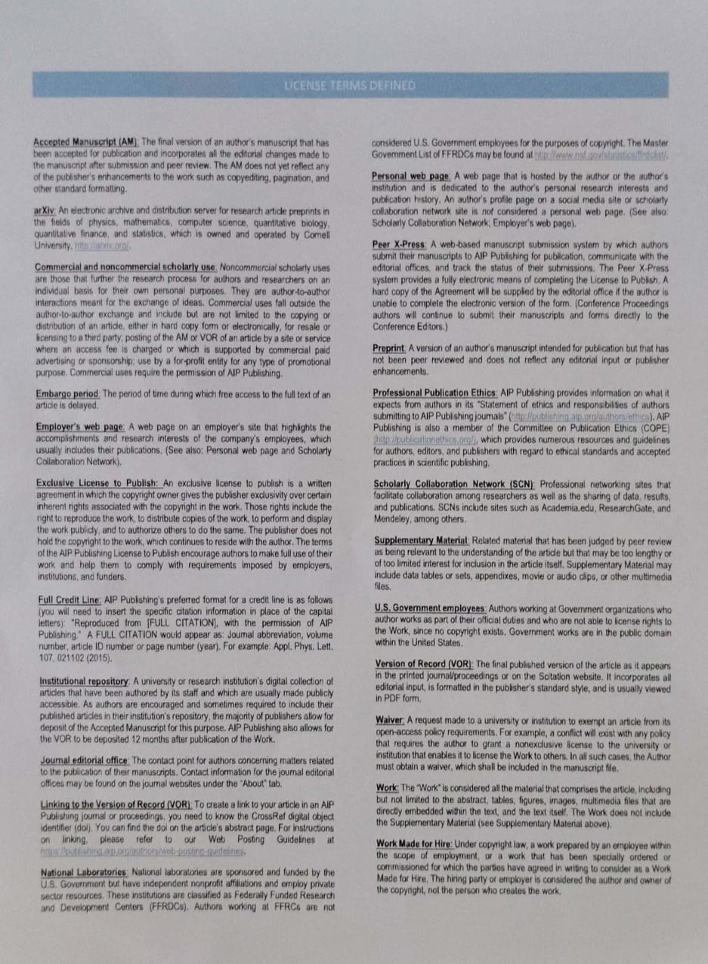

**ACKNOWLEDGMENT**

First and foremost, I would like to express my gratefulness to our honorable Chairman **Sri. C Valliappa** our Vice Chairman **Sri. Chocka Valliappa** and **Sri Thyagu Valliappa** and the management of Sona College of Technology for bring me constant encouragement throughout this course.

My Sincere thanks goes to **Dr. S. R. R. Senthil Kumar**, Principal. Sona College of Technology, who has motivated me in my entire endeavors. I wholeheartedly thank **Dr. B. Sathiyabhama**, Professor and Head Department of Computer Science and Engineering, Sona College of Technology Salem for giving constant encouragement and rendering all kinds of support throughout the course.

I use this opportunity to express my deepest gratitude and special thanks to my project guide **Ms. K. S. Jayareka,** Assistant Professor, Department of Computer Science and Engineering, Sona College of Technology.

Special thanks go to my class counsellor **Ms. K. S. Jayareka,** Assistant Professor, Department of Computer Science and Engineering, Sona College of Technology.

I would like to thank my parents and all my friends from the bottom of my heart who were always present to help me out and make this project a success. Last but not the least, I would like to express my heartiest thanks and gratefulness to almighty God for his divine blessings, which helped me complete the final year project successfully This project was made possible because of inestimable inputs from everyone involved, directly or indirectly.

**ABSTRACT**

Fake reviews detection attracts many researchers’ attention due to the negative impacts on the society. Most existing fake reviews detection approaches mainly focus on semantic analysis of review’s contents. We propose a novel fake reviews deep learning technique using Long Short-Term Memory (LSTM). The increasing popularity of online review systems motivates malevolent intent in competing sellers and service providers to manipulate consumers by fabricating product/service reviews. Immoral actors use Sybil accounts, bot farms, and purchase authentic accounts to promote products and vilify competitors. Facing the continuous advancement of review spamming techniques, the research community should step back, assess the approaches explored to date to combat fake reviews, and regroup to define new ones. This study reviews the literature on Fake Review Detection (FRD) on online platforms. It covers both basic research and commercial solutions, and discusses the reasons behind the limited level of success that the current approaches and regulations have had in preventing damage due to deceptive reviews.

**TABLE OF CONTENT**

|  |  |  |
| --- | --- | --- |
| **CHAPTER NO** | **TITLE** | **PAGE NO** |
|  | **ACKNOWLEDGMENT** | **ix** |
|  | **ABSTRACT** | **x** |
|  | **LIST OF FIGURES** | **xiii** |
| **1** | **INTRODUCTION** | **1** |
|  | 1.1 OVERVIEW | 1 |
|  | 1.2 PROBLEM STATEMENT | 2 |
|  | 1.3 OBJECTIVE OF PROJECT | 2 |
|  | 1.4 SCOPE OF PROJECT | 3 |
| **2** | **LITERATURE SURVEY** | **4** |
|  | 2.1 RESEARCH WORK | 4 |
| **3** | **SYSTEM SPECIFICATIONS** | **11** |
|  | 3.1 HARDWARE REQUIREMENTS | 11 |
|  | 3.2 SOFTWARE REQUIREMENTS | 11 |
|  | 3.3 SOFTWARE DESCRIPTION | 12 |
| **4** | **SYSTEM ANALYSIS** | **14** |
|  | 4.1 EXISTING SYSTEM | 14 |
|  | 4.2 PROPOSED SYSTEM | 14 |
|  | 4.3 ALGORITHM | 15 |
| **5** | **DESIGN AND IMPLEMENTATION** | **17** |
|  | 5.1 MODULES | 17 |
|  | 5.2 ARCHITECTURE DIAGRAM | 19 |
|  | 5.3 CLASS DIAGRAM | 19 |
|  | 5.4 USE CASE DIAGRAM | 20 |
|  | 5.5 SEQUENCE DIAGRAM | 21 |

|  |  |  |
| --- | --- | --- |
| **6** | **CONCLUSION AND FUTURE WORK** | 22 |
|  | 6.1 CONCLUSION | 22 |
|  | 6.2 FUTURE WORKS | 22 |
|  | **APPENDICES** | 24 |
|  | 1. SAMPLE CODE | 24 |
|  | 1. SCREENSHOTS | 40 |
|  | **REFERENCES** | 43 |

**LIST OF FIGURES**

|  |  |  |
| --- | --- | --- |
| **FIGURE NO** | **FIGURE NAME** | **PAGE NO** |
|  | 5.2 ARCHITECTURE DIAGRAM | 19 |
|  | 5.3 CLASS DIAGRAM | 19 |
|  | 5.4 USE CASE DIAGRAM | 20 |
|  | 5.5 SEQUENCE DIAGRAM | 21 |

**CHAPTER 1**

**INTRODUCTION**

* 1. **Overview**

In today's digital era, online reviews play a pivotal role in shaping consumer decisions, influencing everything from purchasing choices to brand reputation. However, the proliferation of fake reviews presents a significant challenge to the integrity of online review systems, leading to misinformation and consumer deception. Detecting and mitigating fake reviews has thus become a pressing concern, prompting researchers to explore novel techniques for identifying fraudulent content. In this paper, we propose a novel approach for fake review detection using the Long Short-Term Memory (LSTM) algorithm. The LSTM's ability to capture long-range dependencies in sequential data, our method aims to distinguish between genuine and fake reviews by analyzing the linguistic nuances and temporal patterns present in review texts. We present a comprehensive framework that encompasses data collection, preprocessing, model creation, training, evaluation, and testing, highlighting each step's significance in detecting fake reviews effectively. By combining advanced deep learning techniques with thorough data processing and analysis, our approach seeks to enhance the trustworthiness of online review platforms and empower consumers with reliable information for making informed decisions. Through this research, aim to contribute to the ongoing efforts to combat deceptive practices in online reviews and foster a more transparent and trustworthy digital marketplace.

* 1. **Problem Statement**

The surge in online shopping, particularly during the pandemic, has led to a proliferation of fake reviews on platforms like Flipkart and Amazon. This inundation makes it difficult for consumers to discern between genuine and fraudulent feedback, undermining their trust in online reviews. The pressing need arises for effective methods to sift through this deluge of reviews and identify deceptive ones. Leveraging sophisticated technologies such as Deep Learning and Machine Learning, there's an opportunity to develop algorithms capable of accurately detecting and filtering out fake reviews, ensuring a more reliable online shopping experience for consumers.

* 1. **Objective of project**

The objective of the project is to develop a robust fake review detection technique utilizing Long Short-Term Memory (LSTM) architecture. The system aims to identify and prevent the publication of fake reviews on online marketplaces or review sites. It involves preprocessing review data, including text cleaning and tokenization, to prepare it for analysis. The preprocessed data undergoes classification using the LSTM algorithm, which learns to recognize patterns indicative of fake reviews based on the sequential nature of the text data. By analyzing temporal relationships between words and phrases, the LSTM model can differentiate between genuine and deceptive content. The project seeks to enhance online platforms' ability to combat fake reviews by automatically filtering out fraudulent content. This initiative not only maintains the integrity of review systems but also fosters consumer trust and confidence in online marketplaces.

* 1. **Scope of project**

The project aims to develop a robust fake review detection system utilizing Long Short-Term Memory (LSTM) architecture. It involves preprocessing review data by cleaning text, removing stop words, and tokenizing words to prepare them for analysis. The system implements the LSTM algorithm for sequential data classification, focusing on identifying subtle linguistic cues indicative of fraudulent content. By analyzing temporal relationships between words and phrases, the model aims to differentiate between genuine and fake reviews effectively. The primary goal is to automatically filter out fraudulent content on online platforms, thereby enhancing the integrity of review systems and fostering consumer trust in online marketplaces.

**CHAPTER 2**

**LITERATURE SURVEY**

1. **Fake Reviews Detection using Supervised Machine Learning**

With the continuous evolve of E-commerce systems, online reviews are mainly considered as a crucial factor for building and maintaining a good reputation. Moreover, they have an effective role in the decision-making process for end users. Usually, a positive review for a target object attracts more customers and lead to high increase in sales. Nowadays, deceptive or fake reviews are deliberately written to build virtual reputation and attracting potential customers. Thus, identifying fake reviews is a vivid and ongoing research area. Identifying fake reviews depends not only on the key features of the reviews but also on the behaviors of the reviewers. This paper proposes a machine learning approach to identify fake reviews. In addition to the features extraction process of the reviews, this paper applies several features engineering to extract various behaviors of the reviewers. The paper compares the performance of several experiments done on a real Yelp dataset of restaurants reviews with and without features extracted from users behaviors. In both cases, we compare the performance of several classifiers; KNN, Naive Bayes (NB), SVM, Logistic Regression and Random Forest. Also, different language models of n-gram in particular bi-gram and tri-gram are taken into considerations during the evaluations. The results reveal that KNN(K=7) outperforms the rest of classifiers in terms of f-score achieving best f-score 82.40%. The results show that the f-score has increased by 3.80% when taking the extracted reviewers behavioral features into consideration.

1. **Enhancing NLP Techniques for Fake Review Detection**

We are in the era of internet where people are more techno-savvy and they surf internet before buying a single item. Since buying a product online is easy and convenient these days, people also tending towards it as it save time and sometimes money. Also, many branded products can be bought without thinking much about quality as name is enough for branded item. Nowadays various vendors also advertise their products through social media like Facebook, WhatsApp etc. Thus, it is an extremely important to check their reliability before buying product. Buyer or client wants to check the opinion of other buyers regarding their purchase for that product. Most of the times review given by the user is not considered genuine as review was given without buying it. Sometimes review contains unrelated words. This makes a false impression on another customer and he or she may cancel buying it. Such as activity often referred as fake Review. Thus, detecting fake reviews has become more important issue for customers to make better decision on purchase as well as for the trader to make their products reliable. This paper presents an active learning method for detecting fake and genuine reviews.

1. **Twitter Spam Detection based on Deep Learning**

Twitter spam has long been a critical but difficult problem to be addressed. So far, researchers have developed a series of machine learning-based methods and blacklisting techniques to detect spamming activities on Twitter. According to our investigation, current methods and techniques have achieved the accuracy of around 80%. However, due to the problems of spam drift and information fabrication, these machine-learning based methods cannot efficiently detect spam activities in real-life scenarios. Moreover, the blacklisting method cannot catch up with the variations of spamming activities as manually inspecting suspicious URLs is extremely time-consuming. In this paper, we proposed a novel technique based on deep learning techniques to address the above challenges. The syntax of each tweet will be learned through WordVector Training Mode. We then constructed a binary classifier based on the preceding representation dataset. In experiments, we collected and implemented 10-day real Tweet datasets in order to evaluate our proposed method. We first studied the performance of different classifiers, and then compared our method to other existing text-based methods. We found that our method largely outperformed existing methods. We further compared our method to non-text-based detection techniques. According to the experiment results, our proposed method was more accurate.

1. **Multiple features-based approach for automatic fake news detection on social networks using deep learning**

In recent years, the rise of Online Social Networks has led to proliferation of social news such as product advertisement, political news, celebrity’s information, etc. Some of the social networks such as Facebook, Instagram and Twitter affected by their user through fake news. Unfortunately, some users use unethical means to grow their links and reputation by spreading fake news in the form of texts, images, and videos. However, the recent information appearing on an online social network is doubtful, and in many cases, it misleads other users in the network. Fake news is spread intentionally to mislead readers to believe false news, which makes it difficult for detection mechanism to detect fake news on the basis of shared content. Therefore, we need to add some new information related to user’s profile, such as user’s involvement with others for finding a particular decision. The disseminated information and their diffusion process create a big problem for detecting these contents promptly and thus highlighting the need for automatic fake news detection. In this paper, we are going to introduce automatic fake news detection approach in chrome environment on which it can detect fake news on Facebook. Specifically, we use multiple features associated with Facebook account with some news content features to analyze the behavior of the account through deep learning. The experimental analysis of real-world information demonstrates that our intended fake news detection approach has achieved higher accuracy than the existing state of art techniques.

1. **Opinion fraud detection via neural auto encoder decision forest**

Online reviews play an important role in influencing buyers’ daily purchase decisions. However, fake and meaningless reviews, which cannot reflect users’ genuine purchase experience and opinions, widely exist on the Web and pose great challenges for users to make right choices. Therefore, it is desirable to build a fair model that evaluates the quality of products by distinguishing spamming reviews. We present an end-to-end trainable unified model to leverage the appealing properties from Auto encoder and random forest. A stochastic decision tree model is implemented to guide the global parameter learning process. Extensive experiments were conducted on a large Amazon review dataset. The proposed model consistently outperforms a series of compared methods.

1. **Fake online reviews: Literature review, synthesis, and directions for future research**

Fake online reviews in e-commerce significantly affect online consumers, merchants, and, as a result, market efficiency. Despite scholarly efforts to examine fake reviews, there still lacks a survey that can systematically analyze and summarize its antecedents and consequences. This study proposes an antecedent–consequence–intervention conceptual framework to develop an initial research agenda for investigating fake reviews. Based on a review of the extant literature on this issue, we identify 20 future research questions and suggest 18 propositions. Notably, research on fake reviews is often limited by lack of high-quality datasets. To alleviate this problem, we comprehensively compile and summarize the existing fake reviews-related public datasets. We conclude by presenting the theoretical and practical implications of the current research.

1. **Deceptive consumer review detection: a survey**

Consumer reviews are considered to be of utmost significance in the field of e-commerce, for they have a stronghold in deciding the revenue of a business. When arriving at a purchasing decision, a majority of online consumers rely on reviews since they offer credible means of mining opinions of other consumers regarding a particular product. The trustworthiness of online reviews directly affects a company’s reputation and profitability. Such generation of deceptive reviews which manipulate the purchasing decision of consumers is a persistent and harmful issue. Hence, developing methods to assist businesses and consumers by distinguishing between credible reviews and deceptive reviews remains to be a crucial, yet challenging task. In view of that, this paper unravels prominent techniques that have been proposed to solve the issue of deceptive review detection. Accordingly, the primary goal of this paper is to provide an in-depth analysis of current research on detecting deceptive reviews and to identify the characteristics, strengths, and bottlenecks of those methodologies which may need further improvements.

1. **A Methodological Template to Construct Ground Truth of Authentic and Fake Online Reviews**

The emergence of opinion spam, scholars in recent years have been investigating how to distinguish between authentic and fake online reviews. In this research area however, constructing ground truth has been a tricky problem. When labeled datasets of authentic and fake reviews are unavailable, it becomes impossible to systematically investigate differences between the two. In light of this problem, the goal of this paper is three-fold: (1) To review existing approaches of developing ground truth, (2) To present an improved methodological template to construct ground truth, and (3) To conduct a quality-check of the newly constructed ground truth. The existing approaches are dissected to identify several peculiarities. The new approach invests in mitigating pitfalls in the current approaches. In the newly constructed ground truth, authentic reviews were found to be not easily distinguishable from fake reviews. Finally, new research directions are identified with the hope that scholars would be able to stay ahead in their relentless race against spammers.

1. **A framework for fake review detection in online consumer electronics retailers**

The impact of online reviews on businesses has grown significantly during last years, being crucial to determine business success in a wide array of sectors, ranging from restaurants, hotels to e-commerce. Unfortunately, some users use unethical means to improve their online reputation by writing fake reviews of their businesses or competitors. Previous research has addressed fake review detection in a number of domains, such as product or business reviews in restaurants and hotels. However, in spite of its economic interest, the domain of consumer electronics businesses has not yet been thoroughly studied. This article proposes a feature framework for detecting fake reviews that has been evaluated in the consumer electronics domain. The contributions are fourfold: (i) Construction of a dataset for classifying fake reviews in the consumer electronics domain in four different cities based on scraping techniques; (ii) definition of a feature framework for fake review detection; (iii) development of a fake review classification method based on the proposed framework and (iv) evaluation and analysis of the results for each of the cities under study.

1. **Spam Review Detection Techniques: A Systematic Literature Review**

Online reviews about the purchase of products or services provided have become the main source of users’ opinions. In order to gain profit or fame, usually spam reviews are written to promote or demote a few target products or services. This practice is known as review spamming. In the past few years, a variety of methods have been suggested in order to solve the issue of spam reviews. In this study, the researchers carry out a comprehensive review of existing studies on spam review detection using the Systematic Literature Review (SLR) approach. Overall, 76 existing studies are reviewed and analyzed. The researchers evaluated the studies based on how features are extracted from review datasets and different methods and techniques that are employed to solve the review spam detection problem. Moreover, this study analyzes different metrics that are used for the evaluation of the review spam detection methods. This literature review identified two major feature extraction techniques and two different approaches to review spam detection.

**CHAPTER 3**

**SYSTEM SPECIFICATION**

**3.1 HARDWARE REQUIREMENTS**

The section of hardware configuration is an important task related to the software development insufficient random-access memory may affect adversely on the speed and efficiency of the entire system. The process should be powerful to handle the entire operations. The hard disk should have sufficient capacity to store the file and application.

* Processor - Pentium – IV
* RAM - 4 GB (min)
* Hard Disk - 20 GB

**3.2 SOFTWARE REQUIREMENTS**

A major element in building a system is the section of compatible software since the software in the market is experiencing in geometric progression. Selected software should be acceptable by the firm and one user as well as it should be feasible for the system. This document gives a detailed description of the software requirement specification. The study of requirement specification is focused specially on the functioning of the system. It allows the developer or analyst to understand the system, function to be carried out the performance level to be obtained and corresponding interfaces to be established.

* Operating System : Windows 7 or 8
* Software : python Idle

**3.3 SOFTWARE DESCRIPTION**

**Python Technology:**

**Python** is an interpreter, high-level, general-purpose programming language. It supports multiple programming paradigms, including procedural, object-oriented, and functional programming. **Python** is often described as a "batteries included" language due to its comprehensive standard library.

**Python Programing Language:**

Python is a multi-paradigm programming language. Object-oriented programming and structured programming are fully supported, and many of its features support functional programming and aspect-oriented programming (including by Meta programming and met objects (magic methods)). Many other paradigms are supported via extensions, including design by contract and logic programming.

Python packages with a wide range of functionality, including:

* Easy to Learn and Use
* Expressive Language
* Interpreted Language
* Cross-platform Language
* Free and Open Source
* Object-Oriented Language
* Extensible
* Large Standard Library
* GUI Programming Support
* Integrated

Python uses dynamic typing and a combination of reference counting and a cycle-detecting garbage collector for memory management. It also features dynamic name resolution (late binding), which binds method and variable names during program execution.

Rather than having all of its functionality built into its core, Python was designed to be highly extensible. This compact modularity has made it particularly popular as a means of adding programmable interfaces to existing applications. Van Rossum's vision of a small core language with a large standard library and easily extensible interpreter stemmed from his frustrations with ABC, which espoused the opposite approach.

Python is meant to be an easily readable language. Its formatting is visually uncluttered, and it often uses English keywords where other languages use punctuation. Unlike many other languages, it does not use curly brackets to delimit blocks, and semicolons after statements are optional. It has fewer syntactic exceptions and special cases than C or Pascal.

**CHAPTER 4**

**SYSTEM ANALYSIS**

**4.1 Existing System**

In the existing method, fake Reviews detection multi-task learning model has been presented which is based on the following observations:

(1) Some certain topics have higher percentages of fake reviews;

(2) Some certain news authors have higher intentions to publish fake news. FDML model investigates the impact of topic labels for the fake reviews and introduce contextual information of news at the same time to boost the detection performance on the short fake reviews. The existing methods and regulations have not yet been able to eradicate the damaging effects of fake review activity in practice. In doing so, we point at the difficulties associated with combating the different types of malignant influencers.

**4.1.1 Disadvantage**

* Low accuracy.
* Need to increase the overall performance of the model.
* The existing model unable to detect the fake news for different dataset.

**4.2 Proposed System**

**4.2.1 Overview**

In our proposed method, we introduce a fake review detection technique utilizing Long Short Term Memory (LSTM) architecture. The system involves several steps aimed at identifying and preventing fake reviews from being published on online marketplaces or review sites. Firstly, the system preprocesses the review data, which may include cleaning the text, removing stop words, and tokenizing the words to prepare them for analysis. Next, the preprocessed data undergoes classification using the LSTM algorithm. This step involves feeding the review data into the LSTM model, which learns to recognize patterns indicative of fake reviews based on the sequential nature of the text data. The LSTM algorithm, known for its ability to capture long-range dependencies in sequential data, is well-suited for detecting subtle linguistic cues that may indicate fake reviews. By analyzing the temporal relationships between words and phrases within reviews, the LSTM model can effectively differentiate between genuine and deceptive content. Through the proposed system, we aim to enhance the ability of online platforms to combat fake reviews by automatically identifying and filtering out fraudulent content. This not only helps maintain the integrity of review systems but also promotes consumer trust and confidence in online marketplaces.

**4.2.2 ADVANTAGES**

* Higher accuracy of the model.
* The performance of the model is high.
* The proposed model has ability to work with different kind of dataset.

**4.3 ALGORITHM LONG SHORT-TERM MEMORY (LSTM)**

In the novel approach for fake review detection using the Long Short-Term Memory (LSTM) algorithm. The LSTM algorithm is a type of recurrent neural network (RNN) designed to capture long-term dependencies in sequential data, making it particularly well-suited for analyzing text data such as online reviews. The LSTM algorithm addresses the limitations of traditional RNNs, which struggle to retain information over long sequences due to the vanishing gradient problem. By introducing specialized memory cells and gating mechanisms, LSTM can selectively remember and forget information, allowing it to effectively process sequences of variable length and capture complex patterns over time. In the context of fake review detection, LSTM offers several advantages. It can analyze the temporal relationships between words and phrases within reviews, identifying subtle linguistic cues that may indicate fraudulent behavior. Additionally, LSTM can learn from large amounts of training data, adapting to evolving spamming techniques used by malicious actors. In our proposed system, the LSTM algorithm serves as the core component for classifying reviews as genuine or fake. By leveraging its ability to model sequential data, we aim to enhance the accuracy and robustness of fake review detection methods, ultimately contributing to the integrity of online review systems and protecting consumers from misinformation

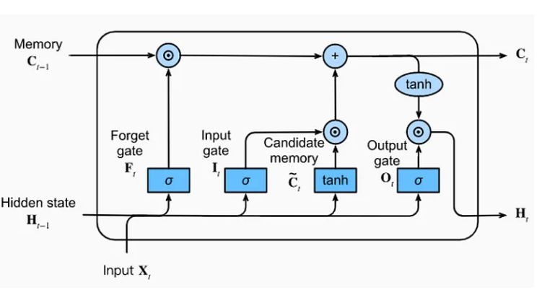

**Fig:4.1 Work Process of LSTM**

**CHAPTER 5**

**DESIGN AND IMPLEMENTATION**

**5.1 Modules and their functionalities**

**5.1.1 Data Collection:**

This module involves gathering review data from online platforms or review websites. The collected data should include both genuine and fake reviews to train and test the LSTM model effectively. Consider scraping data from diverse sources to ensure a representative dataset.

**5.1.2 Pre-processing**:

In this module, the raw review data undergoes preprocessing to prepare it for analysis. Pre-processing steps may include text cleaning to remove HTML tags, punctuation, and special characters, as well as tokenization to break down the text into individual words or tokens. Additionally, techniques such as lowercasing, stop word removal, and stemming or lemmatization may be applied to standardize the text and reduce dimensionality.

**5.1.3 Data Splitting:**

The pre-processed data is divided into training, validation, and testing sets in this module. Typically, the majority of the data is used for training the LSTM model, while smaller portions are allocated for validation and testing to evaluate its performance. Ensure that the data splitting process maintains the balance between genuine and fake reviews across all sets.

**5.1.4 LSTM Model Creation:**

This module involves defining the architecture of the LSTM model. The model comprises input layers, LSTM layers, and output layers. Input layers receive pre-processed text data, while LSTM layers process the sequential information. The output layer produces a probability score indicating the likelihood of a review being fake or genuine. Consider experimenting with different architectures and hyperparameters to optimize the model's performance.

**5.1.5 Model Training:**

In this module, the LSTM model is trained using the training data. Training involves feeding the review sequences into the model, computing the loss between predicted and actual labels, and updating the model's parameters through backpropagation and optimization algorithms such as Adam or SGD. Monitor the training process to prevent overfitting and adjust hyperparameters as needed.

**5.1.6 Model Evaluation:**

After training, the model's performance is evaluated using the validation set. Evaluation metrics such as accuracy, precision, recall, and F1-score are computed to assess how well the model generalizes to unseen data. Conduct comprehensive analyses to understand the strengths and weaknesses of the model and identify areas for improvement.

**5.1.7 Model Testing:**

In this final module, the trained LSTM model is tested on the held-out testing set to measure its performance in a real-world scenario. Evaluate the model's ability to accurately classify reviews as genuine or fake and compare its performance against baseline methods or existing approaches. Provide insights into the effectiveness of the proposed LSTM-based fake review detection technique.

**5.2 Architecture Diagram**

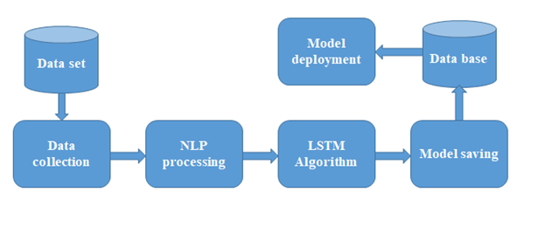

**Fig 5.1 Architecture Diagram**

**5.3 Class Diagram**

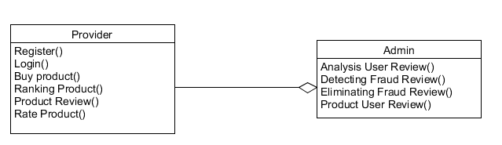

**Fig 5.2 Class Diagram**

**5.4 Use Case Diagram**

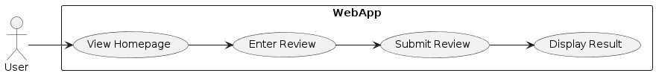

**Fig 5.3 Use case diagram**

**5.5 Sequence Diagram**

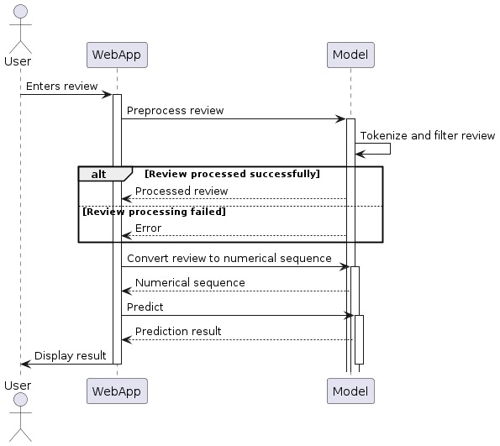

**Fig .4 Sequence Diagram**

**CHAPTER 6**

**CONCLUSION AND FUTURE WORKS**

**6.1 Conclusion**

We focused on the task of identifying spam reviews. After analyzing the reviews in the datasets, we propose a hypothesis that fine-grained aspect information can be used as a new scheme for fake review detection and reconstructed the representation of reviews from four perspectives: users, products, reviews text, and fine-grained aspects. We proposed a multilevel interactive attention neural network model with aspect plan; to optimize the model’s objective function, we transformed the implicit relationship between users, reviews and products into a regularization term. To verify the effectiveness of the MIANA(Multilevel Interactive Attention Neural Network with Aspect Plan), we conducted extensive experiments on three public datasets. Our experiments showed that the classification effect has been significantly improved, that the MIANA outperforms the state-of-the-art methods for fake review detection tasks, and proved the effectiveness and feasibility of our proposed scheme.

**6.2 Future works**

In future endeavours, advancing the sophistication of Deep Learning (DL) architectures holds promise for enhancing the efficiency of fake review detection systems and currently the accuracy stands at 93% in future which can be increased to high percent to identify the fake reviews. Exploring beyond the current state-of-the-art BERT models to more intricate transformer-based architectures like GPT variants could unlock deeper contextual understanding and more nuanced detection capabilities. Additionally, integrating advanced Natural Language Processing (NLP) techniques, such as attention mechanisms and entity recognition, may offer richer insights into review semantics, enabling more accurate identification of fake content. Furthermore, incorporating domain-specific knowledge and features, such as product metadata and user demographics, could further refine the system's discernment between authentic and fraudulent reviews.

**APPENDICES**

**SAMPLE CODE**

Main.py

from flask import Flask, render_template, request, jsonify

import nltk

from nltk.corpus import stopwords

from nltk.tokenize import RegexpTokenizer, sent_tokenize

from tensorflow.keras.preprocessing.text import Tokenizer

from tensorflow.keras.preprocessing.sequence import pad_sequences

from tensorflow.keras.models import load_model

import numpy as np

nltk.download('stopwords')

app = Flask(__name__)

model = load_model('fake_review.h5') # Load the model at the start to save loading time per request.

def preprocess(reviews):

stop_words = set(stopwords.words("english"))

tokenizer = RegexpTokenizer(r'\w+')

processed_reviews = []

for review in reviews:

words = []

sentences = sent_tokenize(review.lower())

for sentence in sentences:

tokens = tokenizer.tokenize(sentence)

filtered_words = [w for w in tokens if w not in stop_words and len(w) > 1]

words.extend(filtered_words)

processed_reviews.append(words)

return processed_reviews

def convert_text_to_no(reviews):

tokenizer = Tokenizer()

tokenizer.fit_on_texts(reviews)

sequences = tokenizer.texts_to_sequences(reviews)

maxlen = 100

return pad_sequences(sequences, maxlen=maxlen)

@app.route('/')

def index():

return render_template('index.html')

@app.route('/predict', methods=['POST'])

def predict():

review = request.form['review']

processed_review = preprocess([review])

sequence_review = convert_text_to_no(processed_review)

sequence_review = np.array(sequence_review, dtype=np.float32)

prediction = model.predict(sequence_review)

result = "Original Review" if prediction[0] >= 0.2 else "Fake Review"

return jsonify(result=result)

if __name__ == '__main__':

app.run(debug=True)

script.js

from flask import Flask, render_template, request, jsonify

import nltk

from nltk.corpus import stopwords

from nltk.tokenize import RegexpTokenizer, sent_tokenize

from tensorflow.keras.preprocessing.text import Tokenizer

from tensorflow.keras.preprocessing.sequence import pad_sequences

from tensorflow.keras.models import load_model

import numpy as np

nltk.download('stopwords')

app = Flask(__name__)

model = load_model('fake_review.h5') # Load the model at the start to save loading time per request.

def preprocess(reviews):

stop_words = set(stopwords.words("english"))

tokenizer = RegexpTokenizer(r'\w+')

processed_reviews = []

for review in reviews:

words = []

sentences = sent_tokenize(review.lower())

for sentence in sentences:

tokens = tokenizer.tokenize(sentence)

filtered_words = [w for w in tokens if w not in stop_words and len(w) > 1]

words.extend(filtered_words)

processed_reviews.append(words)

return processed_reviews

def convert_text_to_no(reviews):

tokenizer = Tokenizer()

tokenizer.fit_on_texts(reviews)

sequences = tokenizer.texts_to_sequences(reviews)

maxlen = 100

return pad_sequences(sequences, maxlen=maxlen)

@app.route('/')

def index():

return render_template('index.html')

@app.route('/predict', methods=['POST'])

def predict():

review = request.form['review']

processed_review = preprocess([review])

sequence_review = convert_text_to_no(processed_review)

sequence_review = np.array(sequence_review, dtype=np.float32)

prediction = model.predict(sequence_review)

result = "Original Review" if prediction[0] >= 0.2 else "Fake Review"

return jsonify(result=result)

if __name__ == '__main__':

app.run(debug=True)

Index.html

<!DOCTYPE html>

<html lang="en">

<head>

<meta charset="UTF-8">

<meta name="viewport" content="width=device-width, initial-scale=1.0">

<title>Fake Review Detector</title>

<!-- Bootstrap CSS -->

<link href="https://stackpath.bootstrapcdn.com/bootstrap/4.5.2/css/bootstrap.min.css" rel="stylesheet">

<!-- Animate.css -->

<link rel="stylesheet" href="https://cdnjs.cloudflare.com/ajax/libs/animate.css/4.0.0/animate.min.css"/>

<style>

body, html {

height: 100%;

margin: 0;

font-family: 'Segoe UI', Tahoma, Geneva, Verdana, sans-serif;

background: #f5f7fa;

color: #333;

}

.bg-gradient {

background-image: linear-gradient(to right top, #65dfc9, #6cdbeb);

height: 100%;

width: 100%;

position: fixed;

top: 0;

left: 0;

z-index: -1;

}

.container {

padding-top: 10%;

}

.btn-primary {

background-color: #6cdbeb;

border: none;

}

.btn-primary:hover {

background-color: #65dfc9;

border: none;

}

.form-control {

border-radius: 0.25rem;

border: 1px solid #ced4da;

}

.form-control:focus {

box-shadow: 0 0 0 0.2rem rgba(108, 221, 235, 0.25);

border-color: #6cdbeb;

}

#reviewForm {

background: white;

padding: 30px;

border-radius: 8px;

box-shadow: 0 6px 20px rgba(0,0,0,0.15);

}

#loader {

display: none; /* Hidden by default, shown during AJAX request */

text-align: center;

color: #6cdbeb;

}

</style>

</head>

<body>

<div class="bg-gradient"></div>

<div class="container">

<div class="row justify-content-center">

<div class="col-md-8">

<h1 class="text-center mb-4">Fake Review Detector LSTM</h1>

<form id="reviewForm" class="needs-validation" novalidate>

<div class="form-group">

<textarea id="reviewText" class="form-control" rows="5" placeholder="Enter your review here..." required></textarea>

<div class="invalid-feedback">Please enter a review.</div>

</div>

<div class="text-center">

<button type="submit" class="btn btn-primary">Check Review</button>

</div>

<div id="loader">Fetching result...</div>

<div id="result" aria-live="polite" class="mt-3"></div>

</form>

</div>

</div>

</div>

<script>

document.addEventListener('DOMContentLoaded', function() {

const form = document.getElementById('reviewForm');

const reviewText = document.getElementById('reviewText');

const loader = document.getElementById('loader');

const result = document.getElementById('result');

form.addEventListener('submit', function(e) {

e.preventDefault();

loader.style.display = 'block'; // Show loader

fetch('/predict', {

method: 'POST',

headers: {

'Content-Type': 'application/x-www-form-urlencoded',

},

body: `review=${encodeURIComponent(reviewText.value)}`

})

.then(response => response.json())

.then(data => {

result.innerHTML = `<span class="firework">🎆</span> ${data.result} <span class="firework">🎆</span>`;

result.className = 'alert alert-success mt-3 animate__animated animate__fadeIn';

loader.style.display = 'none'; // Hide loader

})

.catch(error => {

console.error('Error:', error);

loader.style.display = 'none'; // Hide loader

result.textContent = 'Error fetching results';

result.className = 'alert alert-danger mt-3 animate__animated animate__fadeIn';

});

});

});

</script>

</body>

</html>

Model training code:

import pandas as pd

df=pd.read_csv(r'/kaggle/input/fake-review/fake reviews dataset.csv')

'''

replace the column label

CG ==> 0

OR ==> 1

filter only the column label and text_

'''

df.replace(to_replace = 'OR' , value ='1',inplace=True)

df.replace(to_replace = 'CG' , value ='0',inplace=True)

df.shape

df=df[['label','text_']]

df.sample(5)

'''

replace the column label

CG ==> 0

OR ==> 1

filter only the column label and text_

'''

df.replace(to_replace = 'OR' , value ='1',inplace=True)

df.replace(to_replace = 'CG' , value ='0',inplace=True)

df.shape

df=df[['label','text_']]

df.sample(5)

import nltk

def preprocess(reviews):

stop_words = set(nltk.corpus.stopwords.words("english"))

tokenizer = nltk.tokenize.RegexpTokenizer(r'\w+')

x=[]

for par in reviews:

tmp = []

sentences = nltk.sent_tokenize(par)

for sent in sentences:

sent = sent.lower()

tokens = tokenizer.tokenize(sent)

filtered_words = [w.strip() for w in tokens if w not in stop_words and len(w) > 1]

tmp.extend(filtered_words)

x.append(tmp)

return x

x = preprocess(df['text_'])

from tensorflow.keras.preprocessing.text import Tokenizer

from tensorflow.keras.preprocessing.sequence import pad_sequences

vocab_size = 0

def convert_text_to_no(x):

global vocab_size

tokenizer = Tokenizer()

tokenizer.fit_on_texts(x)

x=tokenizer.texts_to_sequences(x)

maxlen = 100

word_index = tokenizer.word_index

vocab_size = len(tokenizer.word_index) + 1

return pad_sequences(x, maxlen=maxlen)

x=convert_text_to_no(x)

from tensorflow.keras.models import Sequential

from tensorflow.keras.layers import Dense, Embedding, LSTM

#Defining Neural Network

model = Sequential()

#Non-trainable embeddidng layer

model.add(Embedding(

input_dim=vocab_size,

output_dim=2,

input_shape=(100,)

))

model.add(LSTM(units=128))

model.add(Dense(1, activation='sigmoid'))

model.compile(optimizer='adam', loss='binary_crossentropy', metrics=['acc'])

from sklearn.model_selection import train_test_split

import numpy as np

X_train, X_test, y_train, y_test = train_test_split(x, df['label'].values)

X_train = np.array(X_train,dtype=np.float32)

X_test = np.array(X_test,dtype=np.float32)

y_train = np.array(y_train,dtype=np.float32)

y_test = np.array(y_test,dtype=np.float32)

y_pred = (model.predict(X_test) >= 0.5).astype("int")

from sklearn.metrics import accuracy_score

accuracy_score(y_test, y_pred)

model.save('fake_review.h5')

from tensorflow.keras.models import load_model

model = load_model(r'/kaggle/working/fake_review.h5')

review_text = input("")

review_text = preprocess([review_text])

review_text = convert_text_to_no(review_text)

review_text = np.array(review_text,dtype=np.float32)

result = list(model.predict(review_text))[0]

if result >= 0.2:

print("Original Review")

else:

print("Fake Review")

**SCREENSHOTS**

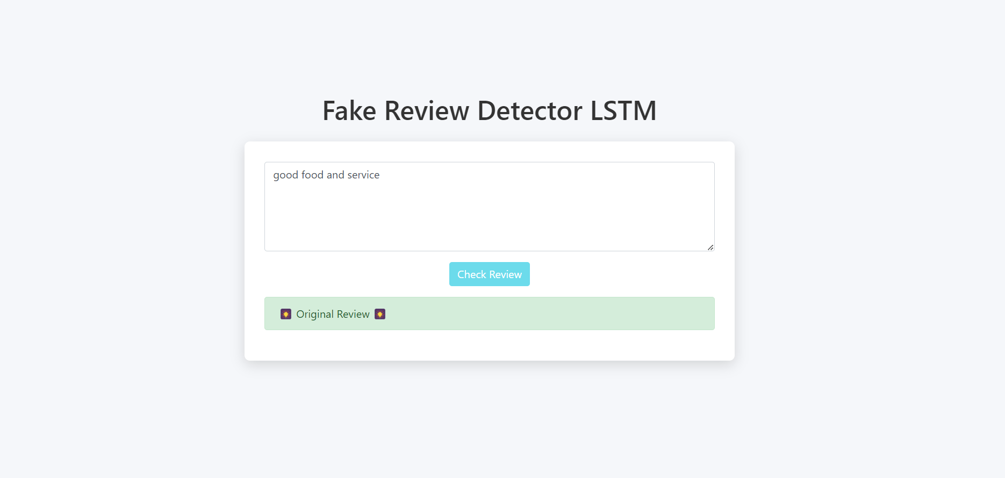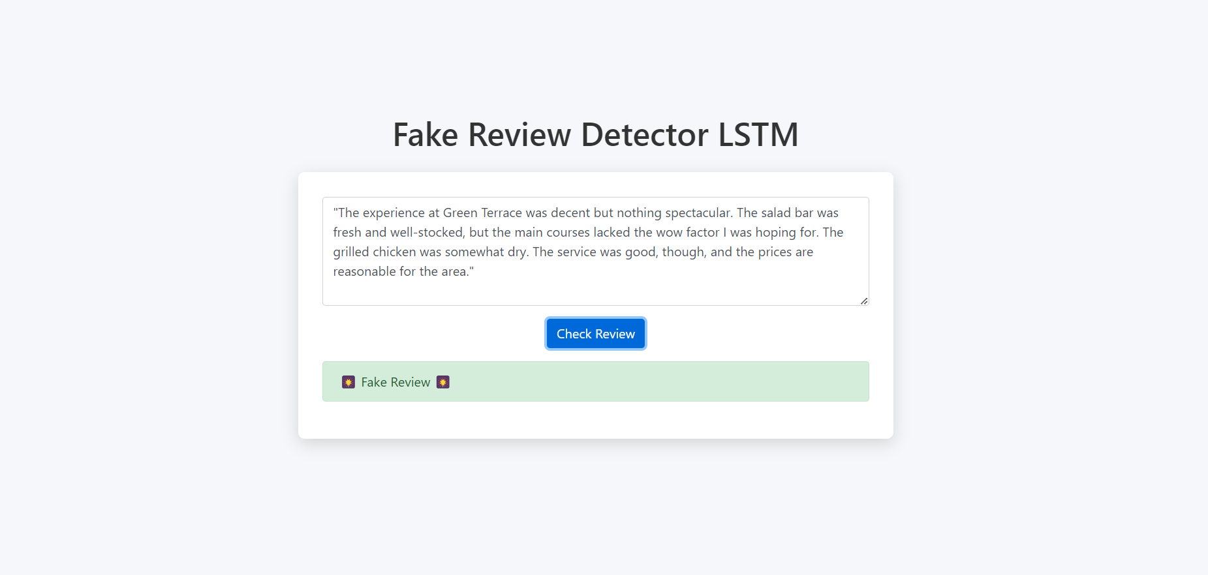

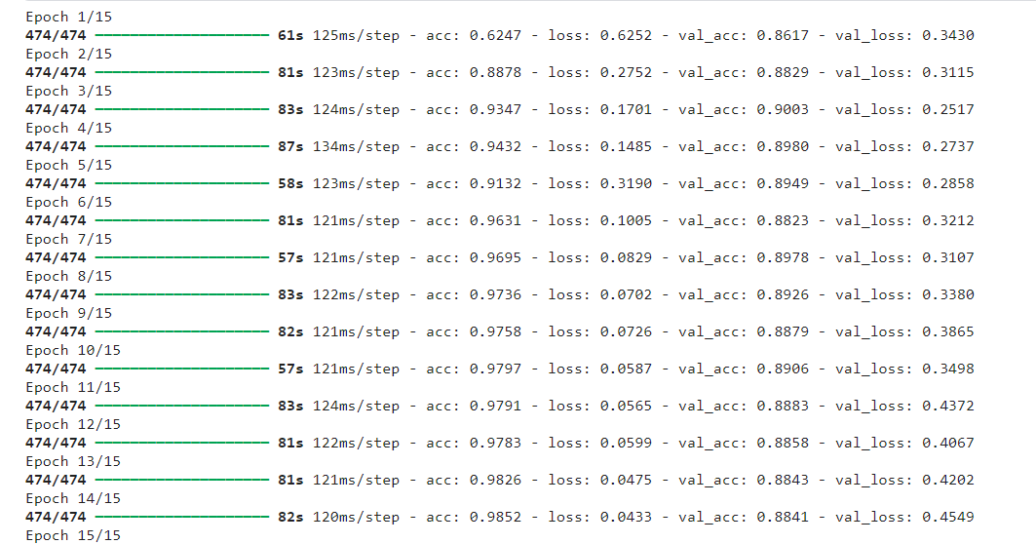

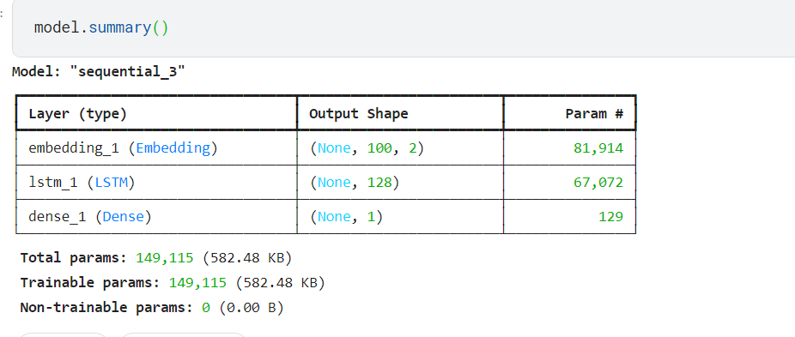

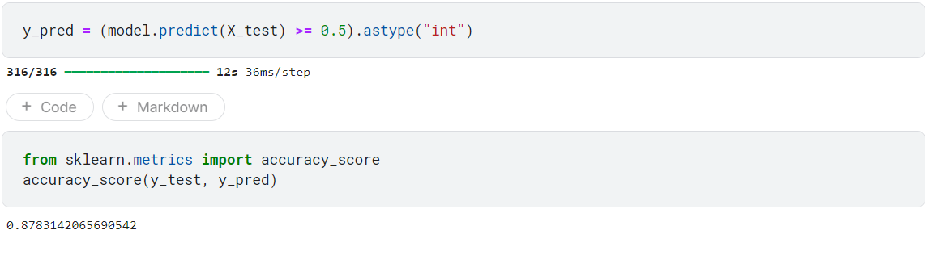

**REFERENCES**

1. Elmogy, A.M., Tariq, U., Ammar, M. and Ibrahim, A., 2021. Fake reviews detection using supervised machine learning. International Journal of Advanced Comp4uter Science and Applications, 12(1).
2. Kashti, M.R.P. and Prasad, P.S., 2019. Enhancing NLP techniques for fake review detection. *Int. Res. J. Eng. Technol. (IRJET)*, *6*, pp.241-245.
3. Alsubari, S.N., Deshmukh, S.N., Alqarni, A.A., Alsharif, N., Aldhyani, T.H., Alsaade, F.W. and Khalaf, O.I., 2022. Data analytics for the identification of fake reviews using supervised learning. *Computers, Materials & Continua*, *70*(2), pp.3189-3204.
4. Wu, T., Liu, S., Zhang, J. and Xiang, Y., January. Twitter spam detection based on deep learning. In *Proceedings of the Australasian computer science week multiconference* (pp. 1-8).
5. Sahoo, S.R. and Gupta, B.B., 2021. Multiple features-based approach for automatic fake news detection on social networks using deep learning. *Applied Soft Computing*, *100*, p.106983.
6. Vachane, D., 2021. Online Products Fake Reviews Detection System Using Machine Learning. *Turkish Journal of Computer and Mathematics Education (TURCOMAT)*, *12*(1S), pp.29-39.
7. Shinde, M., Shingate, R., Badgujar, T., Zingade, G. and Kadam–Rawte, M.N., FAKE REVIEW DETECTION SYSTEM.
8. Rout, J.K., Singh, S., Jena, S.K. and Bakshi, S., 2017. Deceptive review detection using labeled and unlabeled data. *Multimedia Tools and Applications*, *76*, pp.3187-3211.
9. Liang B, Su H, Gui L, Cambria E, Xu R (2022) Aspect-based sentiment analysis via affective knowledge enhanced graph convolutional networks. Knowledge-Based Syst 235:107643
10. E. Kauffmann, J. Peral, D. Gil, A. Ferrández, R. Sellers, and H. Mora, ‘‘A framework for big data analytics in commercial social networks: A case study on sentiment analysis and fake review detection for marketing decision-making,’’ Ind. Marketing Manage., vol. 90, pp. 523–537, Oct. 2020.
11. N. Jindal and B. Liu, ‘‘Review spam detection,’’ in Proc. 16th Int. Conf. World Wide Web, pp. 1189–1190
12. A. Mukherjee, V. Venkataraman, B. Liu, and N. S. Glance, ‘‘what yelp fake review filter might be doing,’’ in Proc. ICWSM, pp. 409–418.
13. S. Rayana and L. Akoglu, ‘‘Collective opinion spam detection: Bridging review networks and metadata,’’ in Proc. 21th ACM SIGKDD Int. Conf. Knowl. Discovery Data Mining, pp. 985–994.
14. F. Li, M. Huang, Y. Yang, and X. Zhu, ‘‘Learning to identify review spam,’’ in Proc. IJCAI 22nd Int. Joint Conf. Artif. Intell., vol. 3, pp. 2488–2493.
15. X. Hu, J. Tang, H. Gao, and H. Liu, ‘‘Social spammer detection with sentiment information,’’ in Proc. IEEE Int. Conf. Data Mining, pp. 180–189.
16. S. Kc and A. Mukherjee, ‘‘on the temporal dynamics of opinion spamming: Case studies on yelp,’’ in Proc. 25th Int. Conf. World Wide Web, Apr. 2016, pp. 369–379.
17. Y. Ren and Y. Zhang, ‘‘Deceptive opinion spam detection using neural network,’’ in Proc. 26th Int. Conf. Compute. Linguistics, Tech. Papers COLING, Dec. 2019, pp. 140–150.
18. Fake Review Detection: A Deep Learning Approach with Feature Fusion" by H. Yang, Z. Xiao, and L. He (2021).